**DAILY ONLINE ACTIVITIES SUMMARY**

|  |  |  |  |  |  |  |  |
| --- | --- | --- | --- | --- | --- | --- | --- |
| **Date:** | **21/05/2020** | | | | **Name:** | **Namratha C** | |
| **Sem & Sec** | **8th sem, A sec** | | | | **USN:** | **4AL16CS056** | |
| **Online Test Summary** | | | | | | | |
| **Subject** | | **SMS 2** | | | | | |
| **Max. Marks** | | **60** | | **Score** | | **60** | |
| **Certification Course Summary** | | | | | | | |
| **Course** | **Introduction to Ethical Hacking** | | | | | | |
| **Certificate Provider** | | | **Great Learning** | **Duration** | | | **254 mins** |
| **Coding Challenges** | | | | | | | |
| **Problem Statement:** C Program to Reverse a Linked List in groups of given size | | | | | | | |
| **Status: Completed** | | | | | | | |
| **Uploaded the report in Github** | | | | **Yes** | | | |
| **If yes Repository name** | | | | **Namrathasonu** | | | |
| **Uploaded the report in slack** | | | | **Yes** | | | |

Online Test Details:

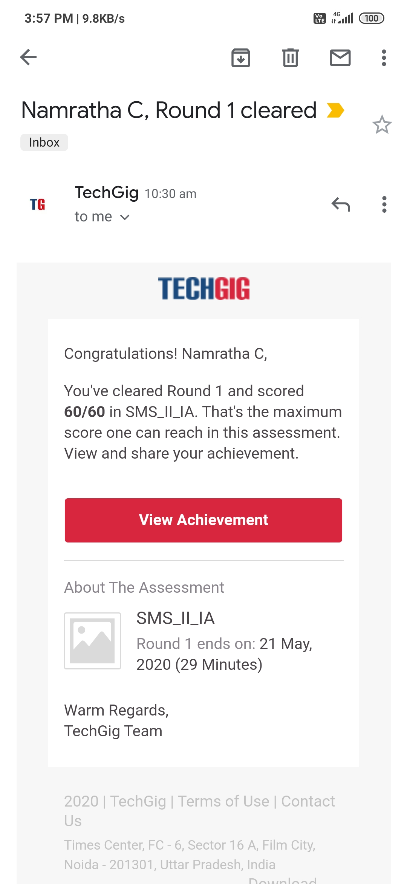

Online examination is conducting a test online to measure the knowledge of the participants on a given topic. With online examination students can do the exam online. The test was on the subject System Modeling and Simulation under the topic Random variate generation technique.

Certification Course Details:

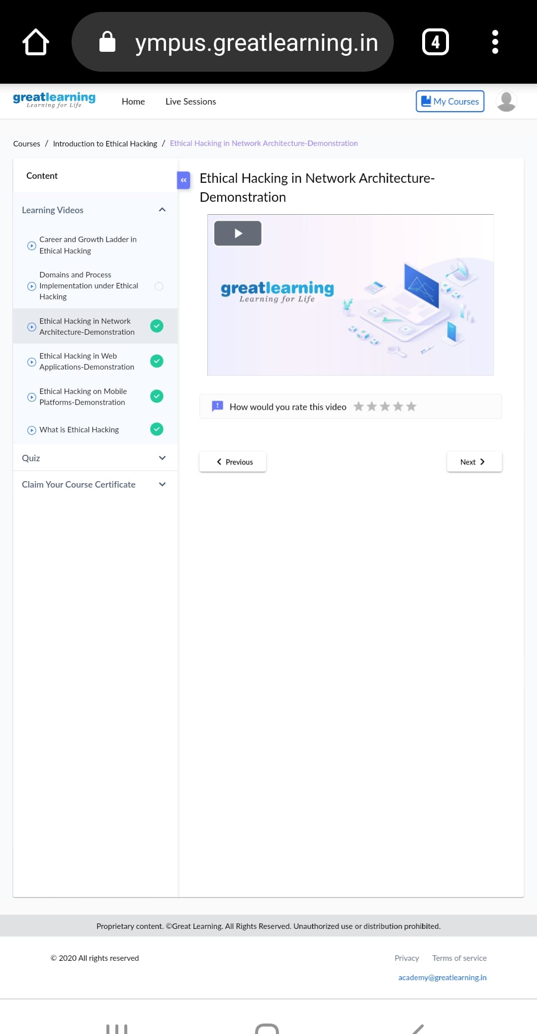

An ethical hacker, also referred to as a white hat hacker, is an information security expert who systematically attempts to penetrate a computer system, network, application or other computing resource on behalf of its owners and with their permission to find security vulnerabilities.

Coding Challenges Details:

